Book Title style sheet

To easily navigate the many sections of this document, open the Navigation menu down the left side of the screen and select the Headings tab. Use the clickable table of contents under Headings to jump to different sections.

Some versions of word will open the Navigation panel if you press Ctrl + N on your keyboard. If not, in the menu ribbon at the top of the document you can click the magnifying glass next to the word Find in the Home tab. See circled areas on screenshot below for guidance:

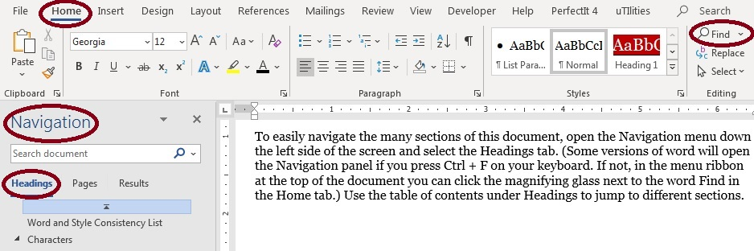

Word and Style Consistency List

This manuscript has been copyedited using Chicago Manual of Style 17th edition as a base style guide. The primary dictionary used for spelling and hyphenation decisions was Oxford Dictionaries Premium US, and the secondary dictionary was Merriam-Webster’s Collegiate Dictionary 11th edition. Clarifications and departures from those sources, per Romance Refined’s house style and author preference, are listed below.

A, B, C, D  Brand/pop culture references:  - Abercrombie & Fitch (ampersand) | E, F, G, H  - façade (w/ accent)  Brand/pop culture references:  - eBay
I, J, K, L  Brand/pop culture references: | M, N, O, P  - okay (not OK)  Brand/pop culture references:
Q, R, S, T  - step-mama (hyphen)  Brand/pop culture references: | U, V, W, X, Y, Z  Brand/pop culture references:

Numbers* | Punctuation & Grammar  - subjunctive used?  - serial comma used?  - italics used for internalized direct speech, including when preceding phrases like “I thought” and “I wondered”?  - keep semicolons in dialogue at a minimum  - ellipses . . . non-breaking space before first point and between each point but regular space after third point; exception: no space between an ellipsis and other punctuation marks  - em dashes—for interruptions and parenthetical phrases, no space either side

Formatting and Microsoft Word Styles
- Heading 1 style for part numbers (if applicable)
- Heading 2 style for chapter numbers
- Heading 3 style for chapter subtitles such as dates and locations
- Scene Break style for asterisks separating scenes
- No Indent style for first paragraph following a chapter heading or a scene break
- Normal style for main body, first line indent set to 0.25 inches
- Block Indent style for letters, emails, headlines, etc. with 0.5 inch indent
- Text Message style in Arial font, italic

*Style rules for numbers:
Most numbers are spelled out in fiction. Digits for the following exceptions:
- numbers 101 and above, excluding two-digit numbers followed by thousands, millions, etc., (e.g. 2,204, but twenty-two thousand), and no superscript with ordinals (101st, not 101st)
- House and room numbers in an address
- phone numbers as 555-555-5555
- times that include hour and minute, but spell out the hour, quarter, and half hour (2:33 a.m. and 2:45 in the morning, but two thirty a.m., two fifteen in the morning, two o’clock)
- years (1985), but spell out decades (the eighties)
- bus, train, plane identifiers
- scores (with no spaces on either side of en dash)
- brands or icons
- weapons
- other common exceptions: 24/7, 4.0 GPA, 9/11 (terrorist attack), 9-1-1 (emergency phone number w/ hyphens), highway numbers, and more

Characters
Full names, nicknames, descriptions, habits, backgrounds, etc.

Most info is copy and pasted straight from the manuscript, which is designated by use of <brackets>, so that references can easily be searched for in the manuscript when updates need to be made.

Main characters

Heroine

PHYSICAL
- <mop of black curls>, blue eyes, expressive face, 19

GENERAL
- <I was raised in Atlanta until I was sixteen.>
- <For eighteen years she’d tried to make her father notice her. Now, she wanted the opposite.>
- has a cat named Bertha

Hero

PHYSICAL

GENERAL

Heroine’s Supporting Cast

Name

Hero’s Supporting Cast

Name

Miscellaneous Cast

Name

Worldbuilding

Civilization

Race

Language

Clothing

Food & Drink

Technology & Science

Architecture

Religion/Beliefs

Government, Laws & Justice

Social Customs & Entertainment

History

Ecosystem

Plants

Animals

Weather

Spatial awareness
Layout for buildings, towns, distance references, etc.

Heroine’s home

Hero’s home
  - 10-minute drive from Jane’s house
  - ground floor
    - <In all my eagerness, I flung open the front door, forgetting all about the coat rack he kept just the other side of it. Down it went in a cacophony of sound. Damn the tiny front hall for ruining my entrance.>
- kitchen: two sinks (utility sink by the back door)

Miscellaneous

Timeline
- Day: the day number is how many days have passed since present day began in chapter one. If month, day of the week, or date is known, it gets listed below the day number.
- Events: summary of each day’s main activities and quotes referencing days of the week, dates, time passing, and cyclical things like moon phases, menstruation/pregnancy related comments, etc. (As with info pasted into character descriptions, quoting the verbatim wording helps for navigating the manuscript when changes need to be made.)
- Chapter: I don’t list page numbers since they can rapidly be thrown off kilter with additions/deletions during edits.
- Color: I use a different color for each calendar year.

Day/Date | Events | Chapter
References to Past Events
2003 | - John’s dad murdered | 2
Mar 2004 | - dad’s killer found guilty | 6
Sept 2004 | - dad’s killer gets new cellmate | 6
Apr 3, 2005 | - dad’s killer found dead in prison cell | 4, 5
Present Day Begins
Day 1  Friday  Jun 2015 | - <Thank God it was Friday and work was almost over.>  - Jane at the office, goes out for drinks with girlfriends, finds her window open at home  - John leaves for a camping trip, has no reception to listen to voicemail left by an unknown number | 1–2
Day 3  Sun | - Jane buys shoes for wedding, tells Tammy <“It’s only two weeks till the big day.”> | 2
Day
Day
Day
Day
Day
Day
Day
Day
Day
Day
Day
Day
Day
Day
Day
Day
Day
Day
Day
Day
Day
Day
Day
Day
Day
Day
Day
Day | - The end!

Favorite Quotes
Useful for promo, uploading to Goodreads, etc.

This is a bonus section (not a standard part of style sheets) I use to note great quotes I may want to use when I help promote the book launch or quotes that authors may want to use for promo.

