Track Changes Tutorial for Microsoft Word 2003

With Track Changes on, it is easy for all parties to see at a glance what has been changed in the text. This tutorial will guide you through the easiest ways to use customizable features of Track Changes to make the tech side of the editing process as smooth as possible. Please note that this tutorial uses directions and screen shots for Word 2003 in Windows.

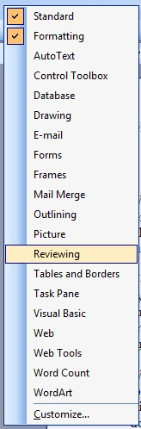You’ll be using Track Changes a lot during your writing career, so make things easy for yourself by adding the Reviewing ribbon to the toolbar at the top of Word for quick access. Right click anywhere in the blue background area of the toolbar (such as to the right of the Help menu) to reveal the toolbar menu (shown right). Standard and Formatting are probably selected by default and possibly a few others. Select Reviewing. Voila! The Reviewing ribbon (shown below) should now be showing.

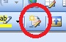To turn Track Changes on and off using this panel, click the button that looks like a piece of lined paper with a pencil. (shown left)

A keyboard shortcut for quickly turning Track Changes on and off is to simultaneously press the CTRL + SHIFT + E keys.

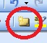Comment bubbles are the best way for us to communicate with each other regarding specific passages. On the Reviewing ribbon, click the New Comment icon, which looks like a file folder (shown left). The word to the left of where your curser is placed will automatically be highlighted and a comment bubble will appear in the margin. If you want to be more specific about what your comment applies to, highlight the words/paragraphs first and then click the New Comment icon.

There are different ways of viewing the edited text. I’ll walk you through my preferences.

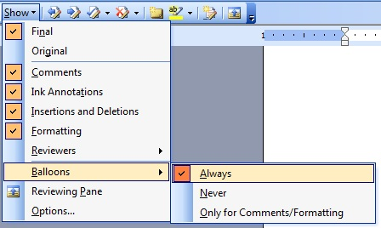I highly recommend viewing edits in balloons. To do this, click Show in the Reviewing ribbon, then Balloons, then Always. This mode keeps the body of the document clean and straightforward. (If you’re following along and are in this mode now, you should see a trail of dots leading to a balloon in the right margin.) The alternative is to Show > Balloons > Only for Comments/Formatting. Switch to this mode now. This option often causes frustrations and leads to mistakes because the body of the document becomes cluttered, and changes, spacing, and punctuation marks can get lost in the sea of color. Please return to Show > Balloons > Always for viewing the rest of this tutorial.
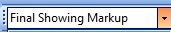By default you’re looking at this document in Final Showing Markup mode. You should see dots leading from a deleted portion of text to a notation in the right margin, added text appears colored, like this, and comments are fully visible in the right margin. A black vertical line should be visible in the left margin next to the line with deleted text. This serves as a visual cue that there is a change somewhere in that line, which is helpful for drawing attention to small changes like punctuation that may otherwise get missed at a glance. This is the viewing mode I would like you to use as you work through your edit. However, if you want to read a clean version of the document, select Final from the dropdown menu.

Another major change that can affect the way you view edits is to view the document in Reading Layout instead of Print Layout. You can access this by clicking View in the toolbar at the top of Word and then selecting Reading Layout or by clicking the icon in the lower left corner of the screen (shown left).

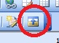The last big option for how you view edits is whether to use the Reviewing Pane. Personally, I find that with Show Balloons Always and Final Showing Markup selected the Reviewing Pane is unnecessary. It also has a tendency to create lag time and freeze. This is personal preference, though, so play around with what works best for you. Access this feature from the last button in the Reviewing ribbon.

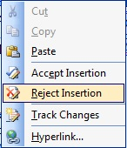Now let’s look at Accept and Reject options. These can be accessed either as the Checkmark and Red X in the reviewing ribbon or by right clicking next to edited text in the body of the document or on a Deleted balloon in the right margin so a small menu pops up. If you are happy with something I’ve edited, no need to use the Accept Insertions feature to individually accept every little thing, just leave as is. (We can do it all in one fell swoop at the end, but more on that in the next paragraph.) If you would like to stet an edit (editing term meaning “let it stand,” used when you don’t want to accept an editor’s change) and the manuscript will be coming back to me, I prefer that you do not use the Reject Deletion feature. Instead—with Track Changes turned on—delete my edit and rewrite your preference. By doing this, when I next see the document your stet will be visible to me, and I’ll be able to learn from the types of edits you tend not to want. If you want to query one of my edits or let me know why you’ve decided against an edit so that I can be guided by your preferences moving forward, create a Comment. If we’re at our final stage of working together and the manuscript will not be seen by me again, feel free to use the Reject option if you find it easiest.

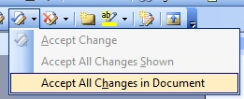After my final edit has been completed on your document and you’ve gone through every line to stet changes by either using the Reject feature or rewriting, you’ll want to create a clean draft for your next editor, the proofreader, formatter, etc. by using the Accept All Changes in Document option. This will incorporate all changes, yours and mine, into the manuscript. Before you click it, though, I recommend you save the document as a new file so you have the Tracked version to refer back to should any queries arise later. You’ll still need to manually delete comment bubbles by right clicking comment and selecting Delete Comment.

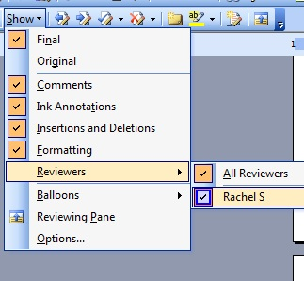The last features I’ll mention give you the ability to view edits based on user and accept only a specific user’s changes. It’s unlikely you’ll need to use these options, but I’ll explain the features in context of how they help an editor so you can understand how and why these features could be put to use.
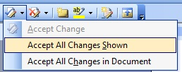After I’ve copyedited a file and sent it to the author for review, the author sends me back a file that shows their new edits as well as my old edits. The first thing I do is go to Show > Reviewers and deselect the author’s name. What this does is show me only my own edits within the document. I know the author has already gone through and deleted the edits they didn’t like from my previous phase of editing, which means they are happy with all of the remaining edits that I’m now looking at. To clean up the document, I then click the downward arrow to the right of the Accept button on the Reviewing ribbon and select Accept All Changes Shown. All of my previous edits are then fully incorporated into the text, and all that remains of my previous work are my comments, which I’ll delete individually. I then go back into Show > Revisions and reselect my author’s name so I can once again see their new material while I read and edit.

And those are all the basics! There are, of course, additional features and settings, and you may prefer alternate settings to what I’ve recommended. Please email with any questions you may have. Happy editing!

